From Evangelical Lutheran Hymn-Book (1918)

61
For Spiritual Illumination.

Grant, we beseech Thee, Almighty God, that the brightness of Thy glory may shine forth upon us, and that the light of Thy light by the illumination of the Holy Spirit may stablish the hearts of all that have been born anew by Thy grace; through our Lord Jesus Christ. Amen.

38
For Mothers.

O Almighty, Everlasting God and Father, Creator of all things, Who by Thy grace, through Thy Son, our Lord, Who hath redeemed us from the flesh and sin, makest the anguish of our human birth a holy and salutary cross; We pray Thee, O gracious Father, Lord and God, that Thou wouldest preserve and guard the work of Thine own hand. Forsake not them who cry to Thee in sore travail, but deliver them out of all their pains to their joy, and to the glory of Thy goodness; through Jesus Christ our Lord. Amen.

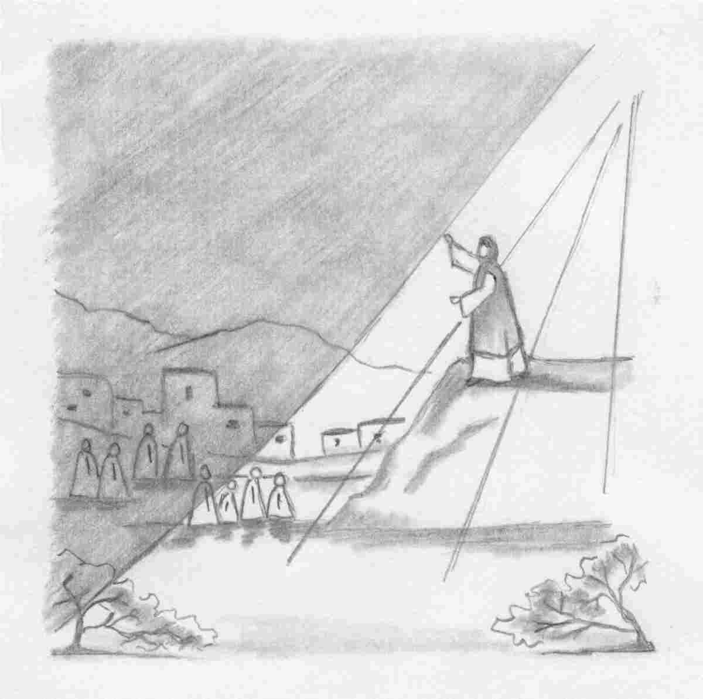
… for those who sat in the region and
shadow of death, Light has dawned.

Our Redeemer Lutheran Church
403 South Hayes
Emmett, Idaho 83617 Church: 208-365-5231

Pastor: Rev. Michael L. McCoy
parsonage: 208-365-5214
email: mmccoy19@earthlink.net
www.scholia.net – the website for:
Good News for the Diaspora!
Music, Litany and Sermons for the Diaspora!
scholia.net publishing – Where the Word is not Bound
Predici in limba romana – (Sermons in Romanian)
The artwork is by Sharon Geiser. Permission to use this copyrighted graphic is limited to congregational use. The Evangelical Lutheran Hymn-Book (Concordia Publishing House, 1918) is in the public domain.

This bulletin cover provided by www.scholia.net and is made available without cost.

23 January Anno Domini 2005

Epiphany 3
… for those who sat in the region and

shadow of death, Light has dawned.
To place the graphic on this page:
Copy the graphic on the previous page.
Click on the open space above and a graphic box should appear. Paste the graphic.

Change this frame and the box above by clicking the body of the text and adding the particulars. (See the previous page for an example.)
The artwork is by Sharon Geiser. Permission to use this copyrighted graphic is limited to congregational use. The Evangelical Lutheran Hymn-Book (Concordia Publishing House, 1918) is in the public domain.

This bulletin cover provided by www.scholia.net and is made available without cost.

23 January Anno Domini 2005

Epiphany 3

From Evangelical Lutheran Hymn-Book (1918)

61
For Spiritual Illumination.

Grant, we beseech Thee, Almighty God, that the brightness of Thy glory may shine forth upon us, and that the light of Thy light by the illumination of the Holy Spirit may stablish the hearts of all that have been born anew by Thy grace; through our Lord Jesus Christ. Amen.

38
For Mothers.

O Almighty, Everlasting God and Father, Creator of all things, Who by Thy grace, through Thy Son, our Lord, Who hath redeemed us from the flesh and sin, makest the anguish of our human birth a holy and salutary cross; We pray Thee, O gracious Father, Lord and God, that Thou wouldest preserve and guard the work of Thine own hand. Forsake not them who cry to Thee in sore travail, but deliver them out of all their pains to their joy, and to the glory of Thy goodness; through Jesus Christ our Lord. Amen.

